**Phase 4 - Product Demand Analysis**

**Abstract:**

Supply and demand are two fundamental concepts of sellers and customers. Predicting demand accurately is critical for organizations in order to be able to make plans. The main aim of our project is to develop a machine learning model (Decision Tree Regression, Random Forest Regression) that forecasts product demand based on historical sales data.

**Feature Engineering:**

The primary goal of this project is to create a predictive model that can estimate the demand for the product in the market under different pricing strategies. By analyzing historical sales data, the project aims to identify the price point at which the product is perceived as a better deal compared to competitors, leading to increased sales.

**Data Collection**: Historical sales data

**Dataset:**[**https://www.kaggle.com/datasets/chakradharmattapalli/product-demand-prediction-with-machine-learning**](https://www.kaggle.com/datasets/chakradharmattapalli/product-demand-prediction-with-machine-learning)

**Dataset Columns:**

The dataset provided for this task includes the following key information:

* **Product ID**: Each product in the company's inventory is assigned a unique identifier, allowing us to distinguish between different items.
* **Store ID**: This represents the specific store or location where the product was sold. It helps in understanding regional variations in demand.
* **Total Price**: This is the actual price at which the product was sold to customers during the sales transaction. It includes any discounts or promotions applied.
* **Base Price**: The base price is the original or standard price at which the product is typically sold before any discounts or promotions are applied.
* **Units Sold (Quantity Demanded)**: This is the quantity of the product that was purchased by customers at a given price point. It reflects the demand for the product at that particular price.

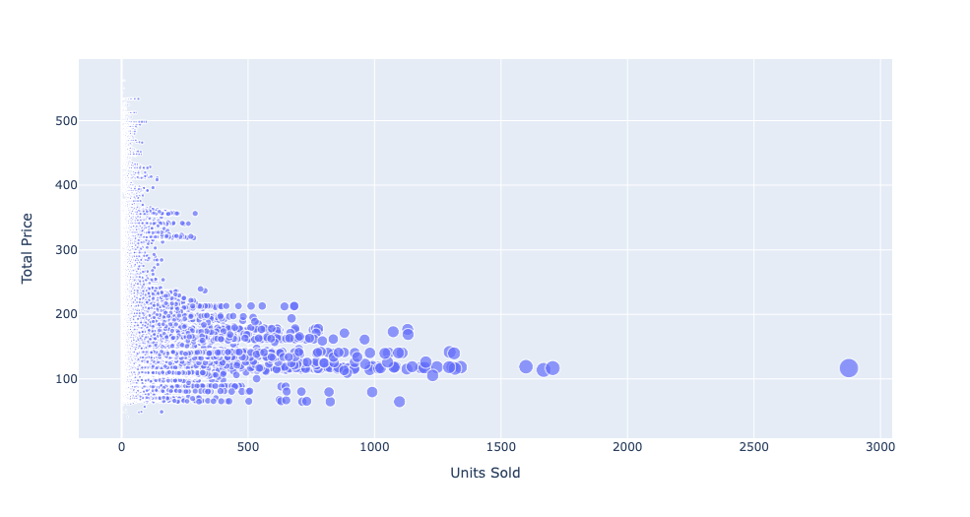

Plot of Total Price vs Units Sold

**Training Data:**

1. **Independent Variables (Features):**
   1. Total Price: The total price of a product.
   2. Base Price: The base price of the product.
2. **Dependent Variable (Target):**
   1. Units Sold: The number of units of the product sold.

During the training phase, the machine learning model uses "Total Price" and "Base Price" as independent variables to predict the "Units Sold."

**Testing Data:**

For model testing or prediction:

1. **Input Features:**
   1. Total Price: The total price of a product.
   2. Base Price: The base price of the product.
2. **Output Feature (Prediction):**
   1. Units Sold: The model will predict the number of units of the product that are expected to be sold based on the provided "Total Price" and "Base Price."

In summary, the trained model takes "Total Price" and "Base Price" as input and predicts the "Units Sold" as the output. This setup allows us to estimate the number of units sold for a given total price and base price combination.

**Data Correlation:**

A correlation matrix is a table showing correlation coefficients between variables. Each cell in the table shows the correlation between two variables. A correlation matrix is used to summarize data, as an input into a more advanced analysis, and as a diagnostic for advanced analyses.

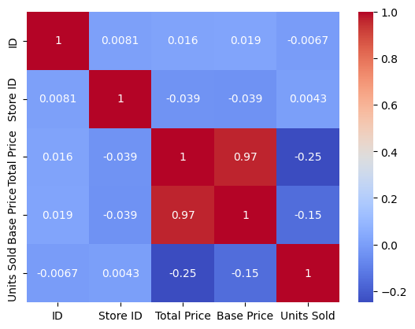

Heat Map for the Correlation Matrix

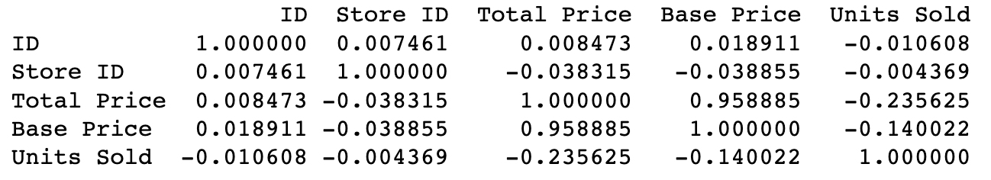

Correlation Matrix

Insights:

1. **Total Price and Base Price (Correlation: 0.958885)** : Total Price and Base Price have a very strong positive correlation. This means that there is a strong linear relationship between the total price and the base price of the products. As the base price increases, the total price tends to increase accordingly.
2. **Total Price and Units Sold (Correlation: -0.235625)** : Total Price and Units Sold have a moderate negative correlation. This suggests that as the total price of the products increases, the number of units sold tends to decrease. Customers may buy fewer units when the price is higher.
3. **Base Price and Units Sold (Correlation: -0.140022)** : Base Price and Units Sold also have a moderate negative correlation. This indicates that as the base price of the products increases, the number of units sold tends to decrease. This relationship is similar to the one observed with total price.

Why does the Linear Regression model fail?

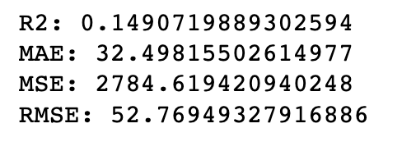

Accuracy Metrics Linear Regression Model

By observing the correlation matrix, high correlation (0.96) among the independent variables and a relatively weak correlation (-0.26) between the dependent and independent variables, linear regression might not be the best choice for modeling this relationship effectively.

Because:

**1. Multicollinearity:**

In linear regression, highly correlated independent variables can lead to multicollinearity. Multicollinearity occurs when two or more independent variables in a regression model are highly correlated, making it difficult for the model to estimate the individual effect of each variable on the dependent variable accurately. This situation can lead to unstable coefficient estimates, making interpretations and predictions unreliable.

**2. Weak Correlation with the Dependent Variable:**

The weak correlation between the independent variables and the dependent variable (-0.26) suggests a weak linear relationship. Linear regression assumes a linear relationship between independent and dependent variables. When the correlation is weak, linear regression might not capture the underlying patterns effectively, leading to poor predictions.

**3. Overfitting**:

In the case of high multicollinearity, linear regression might fit the training data very well (overfitting), but it may fail to generalize to new, unseen data. Overfitting occurs when the model learns the noise in the training data instead of the actual underlying patterns, leading to poor performance on new data.

**Models used:**

* Decision Tree Regressor
* GradientBoostingRegressor
* RandomForestRegressor

**Model Training:**

Training and testing a machine learning model involves several steps.

* **Data Splitting:** The train_test_split function is used to split the dataset into training and testing sets. This allows us to train the model on one subset of the data and test its performance on another, unseen subset.

***train_test_split*** is a function from the sklearn.model_selection module in scikit-learn. It's a commonly used function for splitting a dataset into two subsets: one for training our machine learning model and the other for testing its performance.

**train_test_split Function:**

The train_test_split function splits arrays or matrices into random train and test subsets. It takes several parameters, including your features (X) and labels (y), and splits them into four subsets: X_train, X_test, y_train, and y_test.

**SOURCE CODE:**

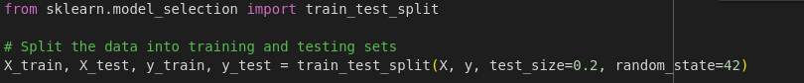

* **X** is a feature matrix.
* **y** is the target variable (labels).
* **test_size** is the proportion of the dataset to include in the test split. In this case, 20% of the data will be used for testing (test_size=0.2).
* **random_state** is a seed for the random number generator. Providing a specific seed ensures reproducibility. Different seeds will result in different random splits.

After running the code, we will have four datasets:

* **X_train**: The features for training your model.
* **X_test**: The features for testing your model.
* **y_train**: The corresponding labels for training.
* **y_test**: The corresponding labels for testing.
* **Model Initialization:** The machine learning model (Random Forest Regressor in this case) is initialized with specified hyperparameters
* **Training the Model:** The fit function is used to train the model using the training data (X_train and y_train).

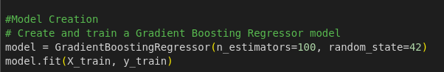

* **Making Predictions:** The trained model is used to make predictions on the test data (X_test). The resulting predictions are stored in the predictions variable.

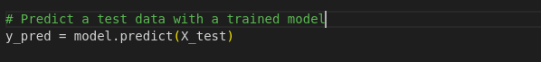

**Accuracy Comparison:**

**Decision Tree**

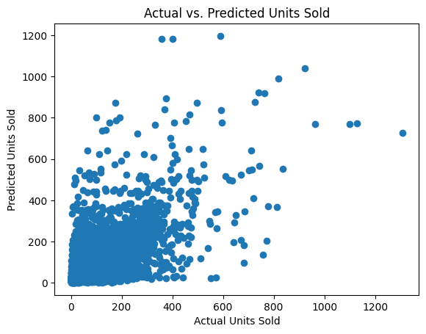

Decision Tree Regression Model:

Plot of Actual Units Sold vs Predicted Units Sold

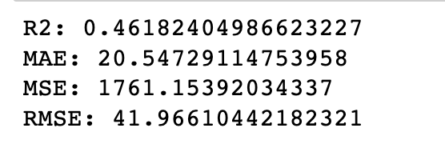

Accuracy Metrics for Decision Tree

**Random Forest**

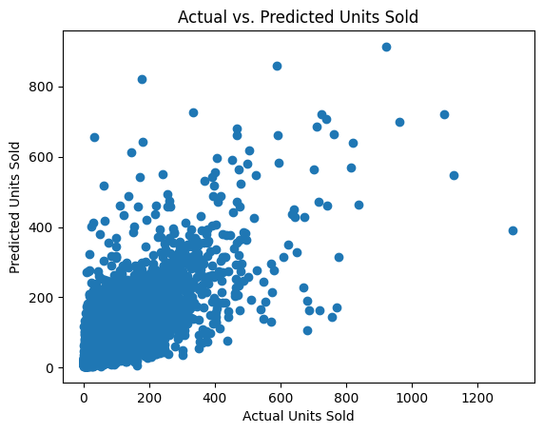

Random Forest Regression Model:

Plot of Actual Units Sold vs Predicted Units Sold

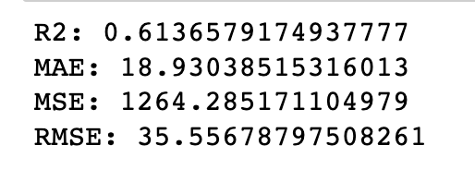

Accuracy Metrics for Random Forest Model

**Gradient Boosting**

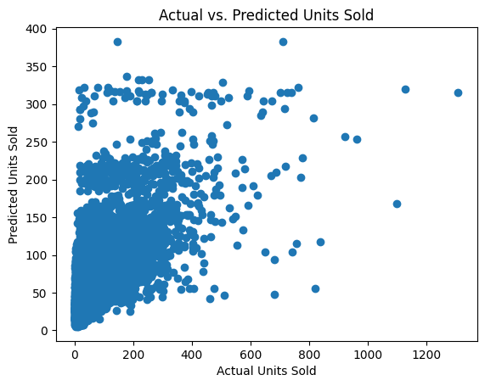

Gradient Boosting Regression Model:

Plot of Actual Units Sold vs Predicted Units Sold

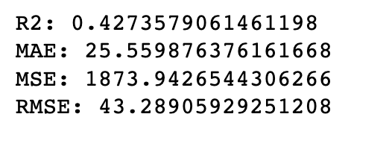

Accuracy Metrics for Gradient Boosting Model

**Model Evaluation:**

**R-Squared(R2)**

R2, or the coefficient of determination, measures how well a regression model predicts the variance in the dependent variable. It ranges from 0 to 1, where 1 indicates perfect predictions. It's a handy tool to evaluate the goodness of fit in regression analysis.

**Mean Absolute Error (MAE):**

Mean Absolute Error (MAE) is a metric that calculates the average absolute differences between predicted and actual values in a dataset. It provides a straightforward measure of prediction accuracy. With MAE, the absolute errors are summed up and divided by the number of observations, giving a clear average error value. Unlike some other metrics, MAE treats all errors equally, making it robust and easy to interpret.

**Mean Squared Error (MSE):**

Mean Squared Error (MSE) measures the average of the squared differences between predicted and actual values. It's a common metric in regression analysis. Squaring the errors emphasizes larger discrepancies, giving a comprehensive view of overall model performance. However, because it squares the errors, it's sensitive to outliers.

**Root Mean Squared Error (RMSE):**

Root Mean Squared Error (RMSE) is the square root of the Mean Squared Error (MSE). It shares the same intuitive interpretation as the original data's unit, making it more easily understandable. RMSE penalizes large errors, offering a balanced view of prediction accuracy. Like MSE, it's widely used in regression analysis. Lower RMSE values indicate better model performance, and it provides a sense of the average magnitude of prediction errors in the original units of the data.

**Comparison of Models**

|  |  |  |  |
| --- | --- | --- | --- |
|  | **Decision Tree** | **Random Forest** | **Gradient Boosting** |
| **R-squared** | 0.46 | 0.61 | 0.43 |
| **Mean Absolute Error (MAE)** | 20.55 | 18.93 | 25.56 |
| **Mean Squared Error (MSE)** | 1761.15 | 1264.28 | 1873.94 |
| **Root Mean Squared Error**  **(RMSE)** | 41.97 | 35.56 | 43.29 |

**Conclusion:**

In conclusion, after thorough evaluation of Random Forest, Gradient Boosting, and Decision Tree models for product demand prediction, Random Forest emerged as the superior choice with an R-squared score of 0.61. Its exceptional ability to capture complex patterns and provide accurate forecasts positions it as the most reliable model for predicting future product demand, making it the recommended solution for our problem statement.